VPC Task -02

- Create one VPC, with 1 public subnet and 1 private subnet. 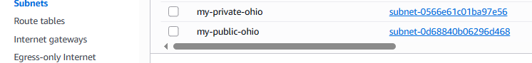
- Enable VPC peering for cross-region. 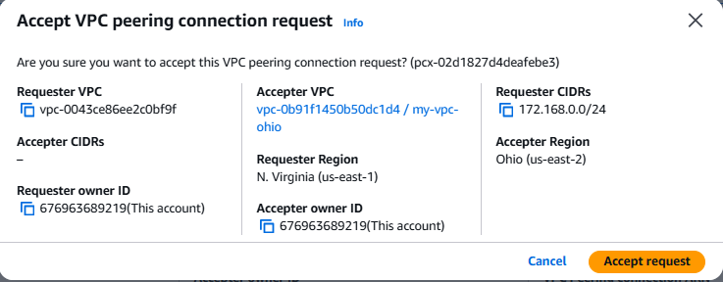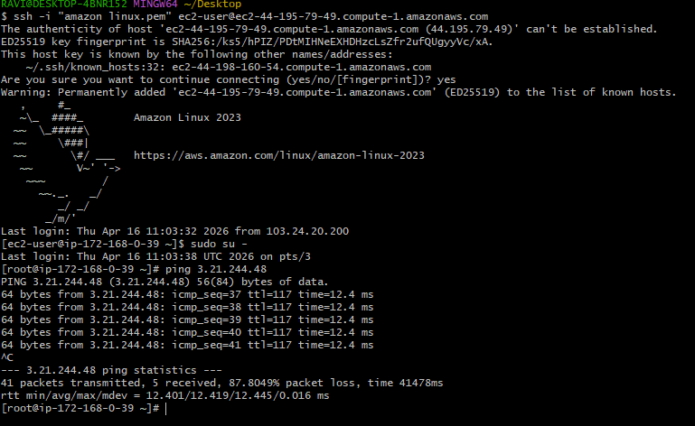

- Enable VPC peering for cross-account (you can collaborate with your friend to do this task). 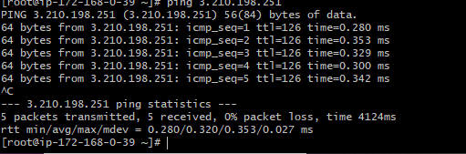
- Set up a VPC Transit Gateway. 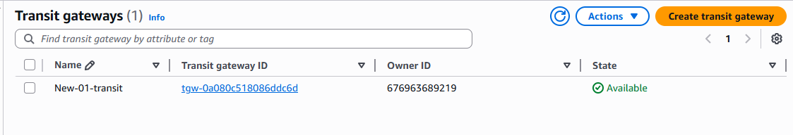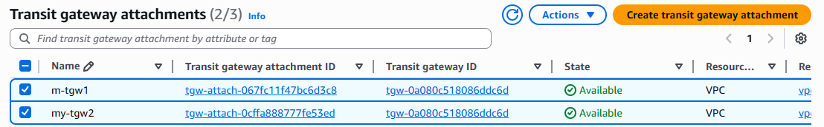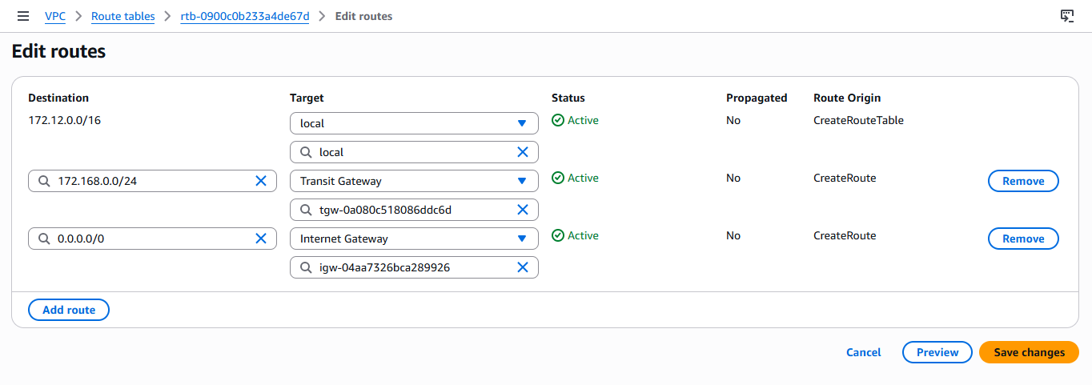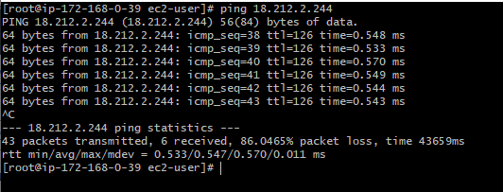

- Set up a VPC Endpoint.
